

MBD PROJECT

# Anti-Lock Braking System



KPIT Technologies Ltd.

Dhanashri Desai 214942

[Dhanashri.Desai@kpit.com](mailto:Dhanashri.Desai@kpit.com)

Content

1. Introduction
2. Block Diagram
3. Component of ABS System
4. Working of ABS
5. Mathematical Model
6. Input Parameter of simulation model of ABS System
7. Solver selection strategy
8. Data Inspector
9. Call Back

10.Signal Builder

11.Look up Table

12. Result of Simulation

1.Introduction

* Anti-lock braking system (ABS) is an automobile safety system that allows the wheels on a motor vehicle to maintain tractive contact with the road surface according to driver inputs while braking, preventing the wheels from locking up and avoiding uncontrolled skidding.
* ABS generally offer improved vehicle control and decreases stopping distances on dry and slippery surfaces.
* ABS modulate the brake line pressure independent of the pedal force, to bring the wheel speed back to the slip level range that is necessary for optimal braking performance.

2.Block Diagram

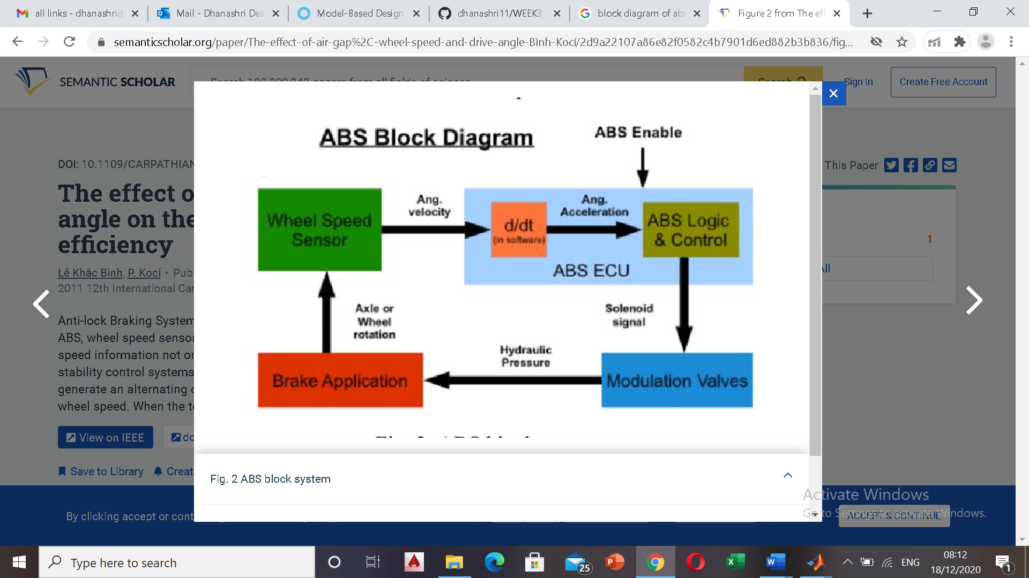

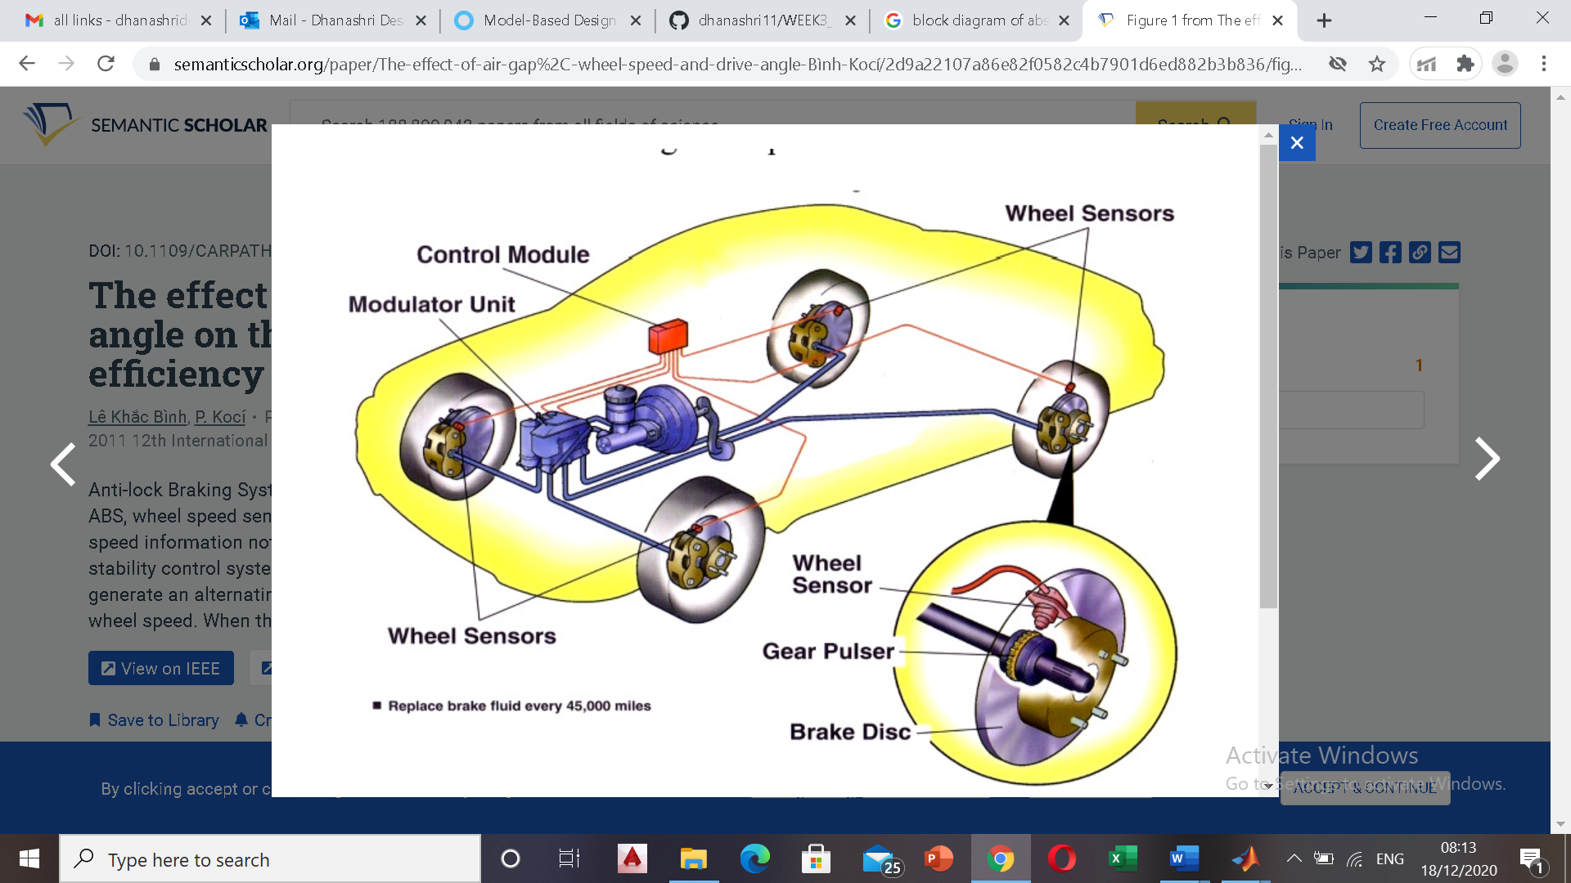

3.Component of ABS system

The primary components of the ABS braking system are:

* Electronic control unit (ECU)

1.It receives signals from the sensors in the circuit and controls the brake

pressure at the road wheels according to the data analyzed by the Unit.

2.ECU assists the vehicle operator to prevent wheel lockup by regulating the wheel slip.

* Hydraulic control unit or modulator

1.It receives operating signals from the ECU to apply or release the brakes under ABS conditions.

2.It executes the commands using three solenoid valves connected in series with the master cylinder and the brake circuits- one valve for each front wheel hydraulic circuit, and one for both of the rear wheels. Thus, brakes can be actuated by controlling hydraulic pressure.

* Power booster and master cylinder assembly

1.It is activated when the driver pushes down on the brake pedal. The master cylinder transforms the applied pedal force into hydraulic pressure which is transmitted simultaneously to all four wheels.

2.It provides the power assistance required during braking.

* Wheel sensor unit

1.Speed sensors are comprised of a magnet wrapped in a coil and a toothed sensor ring. An electrical field given off by the contact between the magnet and the toothed ring creates a AC voltage.

2.The voltage frequency is directly proportional to the wheel's rotational speed.

3.It monitors the rotational speed of the wheel and transmits this data to the ABS control module.

4.Working of ABS

* If a wheel-speed sensor signals a lock up - the ECU sends a current to the hydraulic unit. This energizes the solenoid valve. The action of the valve isolates the brake circuit from the master cylinder. This stops the braking pressure at that wheel from rising, and keeps it constant. It allows wheel velocity to increase and slip to decrease.
* When the velocity increases, ECU re-applies the brake pressure to restrict the wheel slip to a particular value.
* Hydraulic control unit controls the brake pressure in each wheel cylinder based on the inputs from the system sensor. This in result controls the wheel speed.

5.Mathamatical model

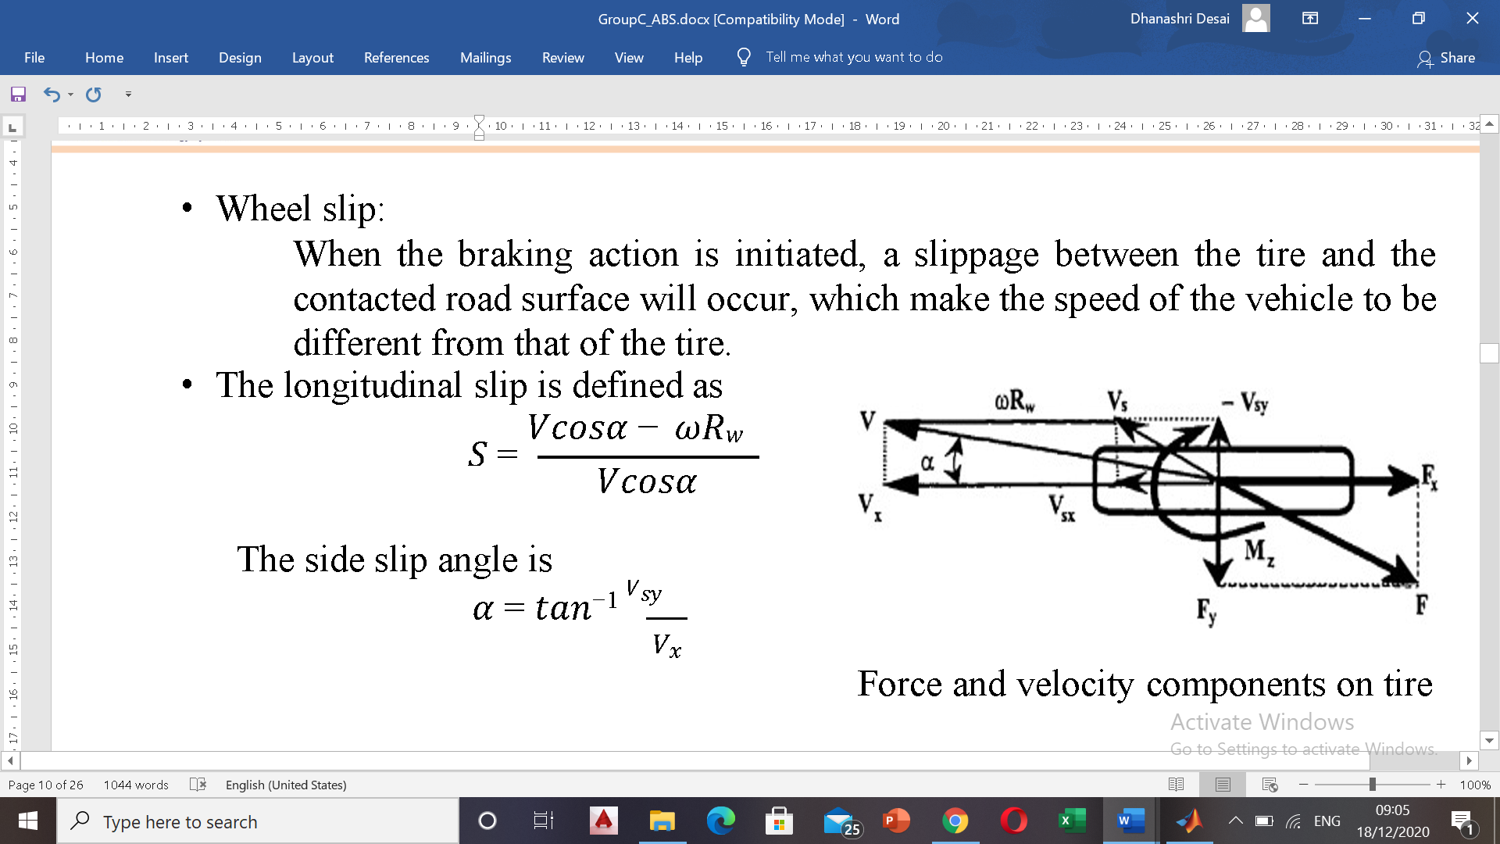

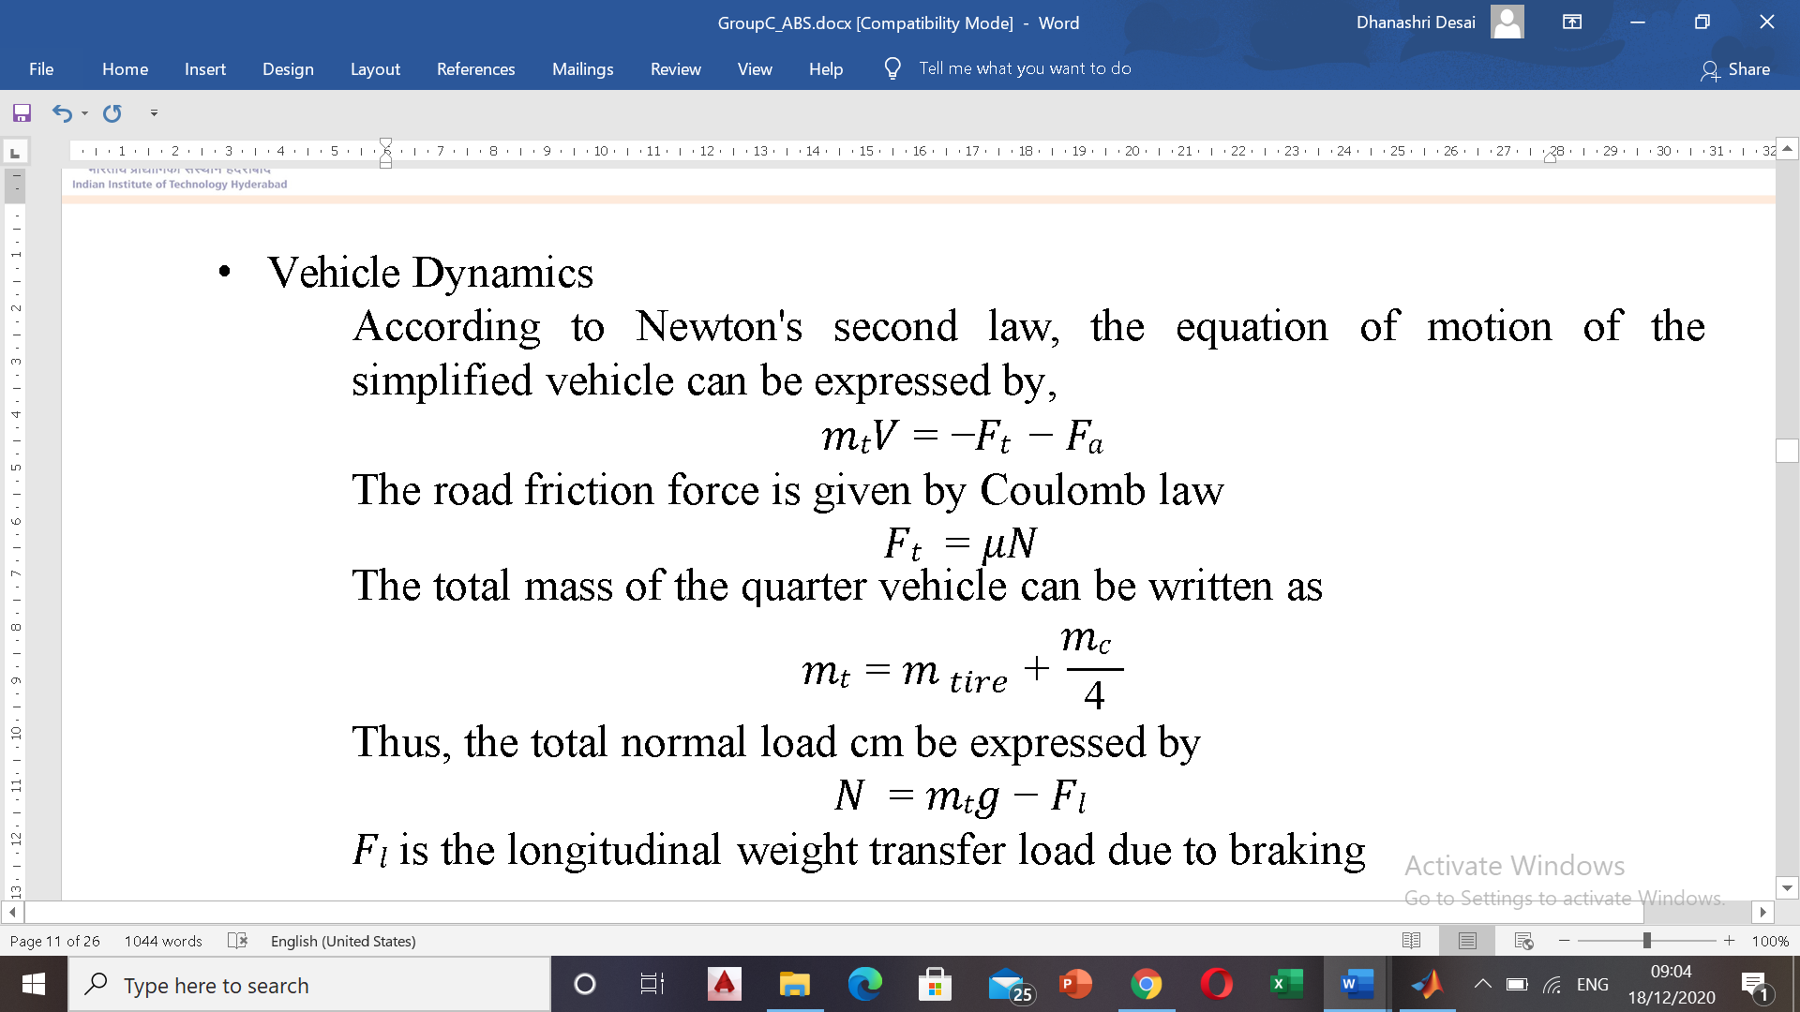

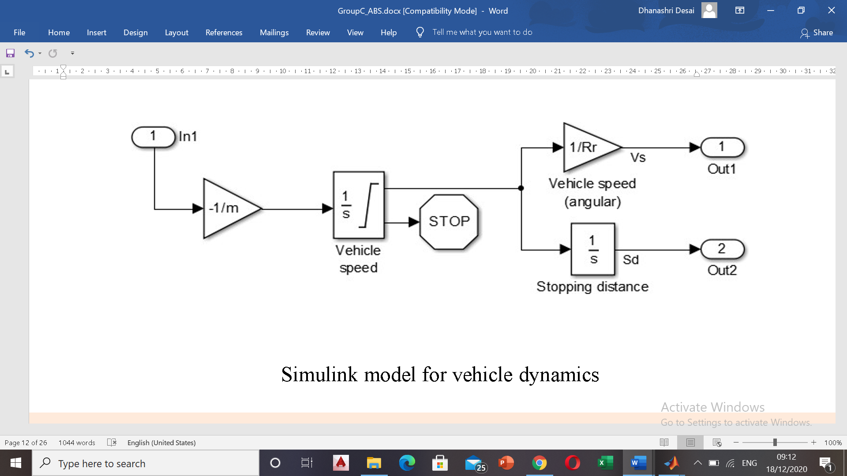

* Wheel dynamics

According to Newton's second law, the equation of motion at wheel

level for the rotational DOF is given by,

𝐽𝑤𝜔 = −𝑇𝑏 + 𝐹𝑡𝑅𝑤

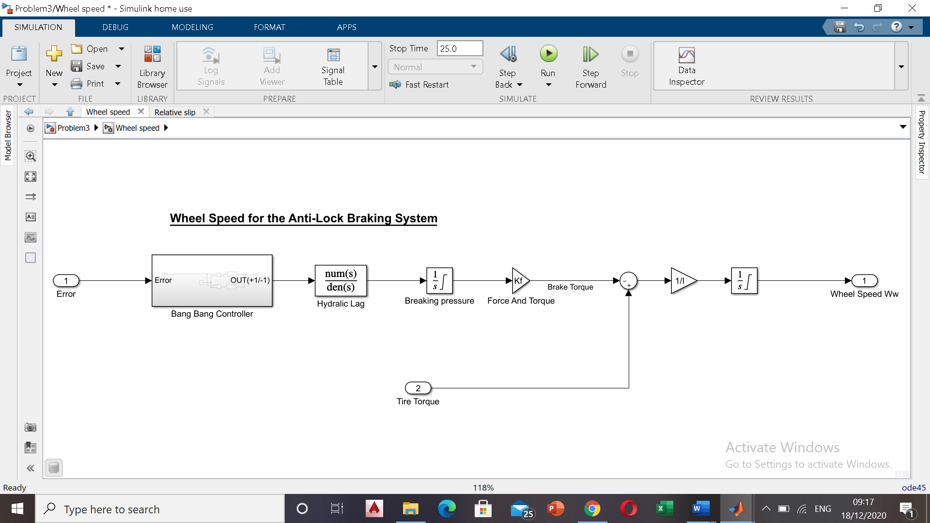

**Simulink model for Wheel Dynamics**

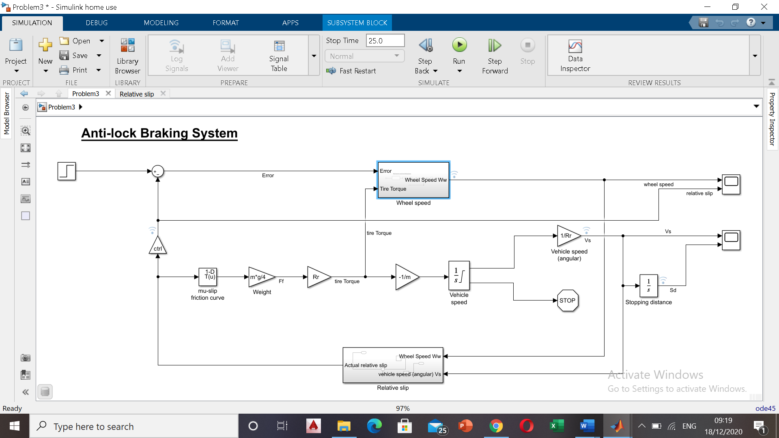

**System Model**

## 6.Input Parameter for Simulink model for ABS System

## 1.Gravitational constant 𝑔 = 32.18 𝑓𝑡/𝑠2

2.Initial velocity of vehicle 𝑣0 = 88 𝑓𝑡/𝑠

3.Wheel Radius 𝑅𝑟 = 1.25 𝑓𝑡

4.Mass of vehicle 𝑚 = 50 lbs.

5.Maximum Braking Torque 𝑇𝑏𝑚𝑎𝑥=1500 𝑙𝑏𝑓*𝑓𝑡

6.Hydraulic Lag 𝑇𝐵 =0.01 𝑠

7.Moment of Inertia 𝐽𝑤 = 5 𝑓𝑡4

7.Solver selection strategy

# ode45

Solve nonstiff differential equations — medium order method

## Syntax

[[t,y] = ode45(odefun,tspan,y0)](https://in.mathworks.com/help/matlab/ref/ode45.html#d122e895996)

[[t,y] = ode45(odefun,tspan,y0,options)](https://in.mathworks.com/help/matlab/ref/ode45.html#d122e896070)

[[t,y,te,ye,ie] = ode45(odefun,tspan,y0,options)](https://in.mathworks.com/help/matlab/ref/ode45.html#d122e896105)

[sol = ode45(**___**)](https://in.mathworks.com/help/matlab/ref/ode45.html#d122e896171)

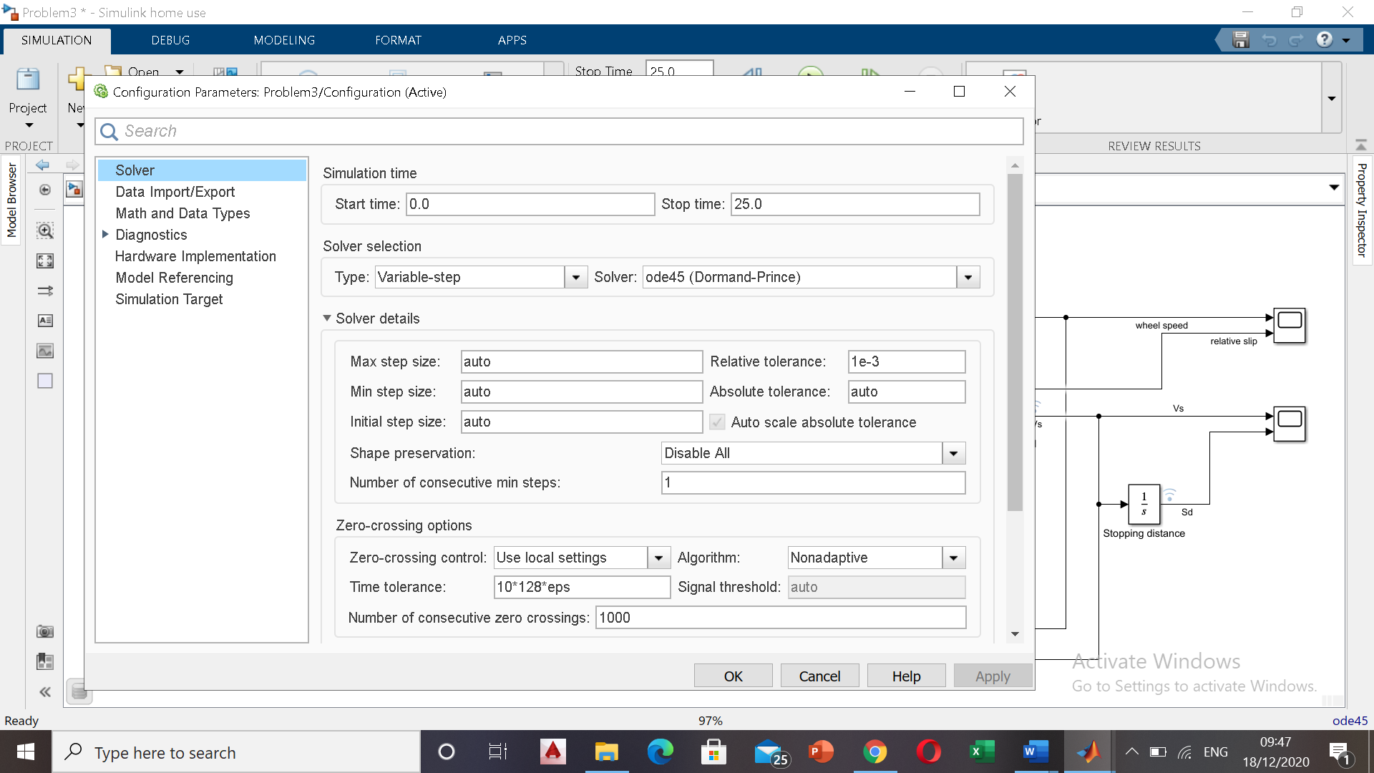

8.Data Inspector

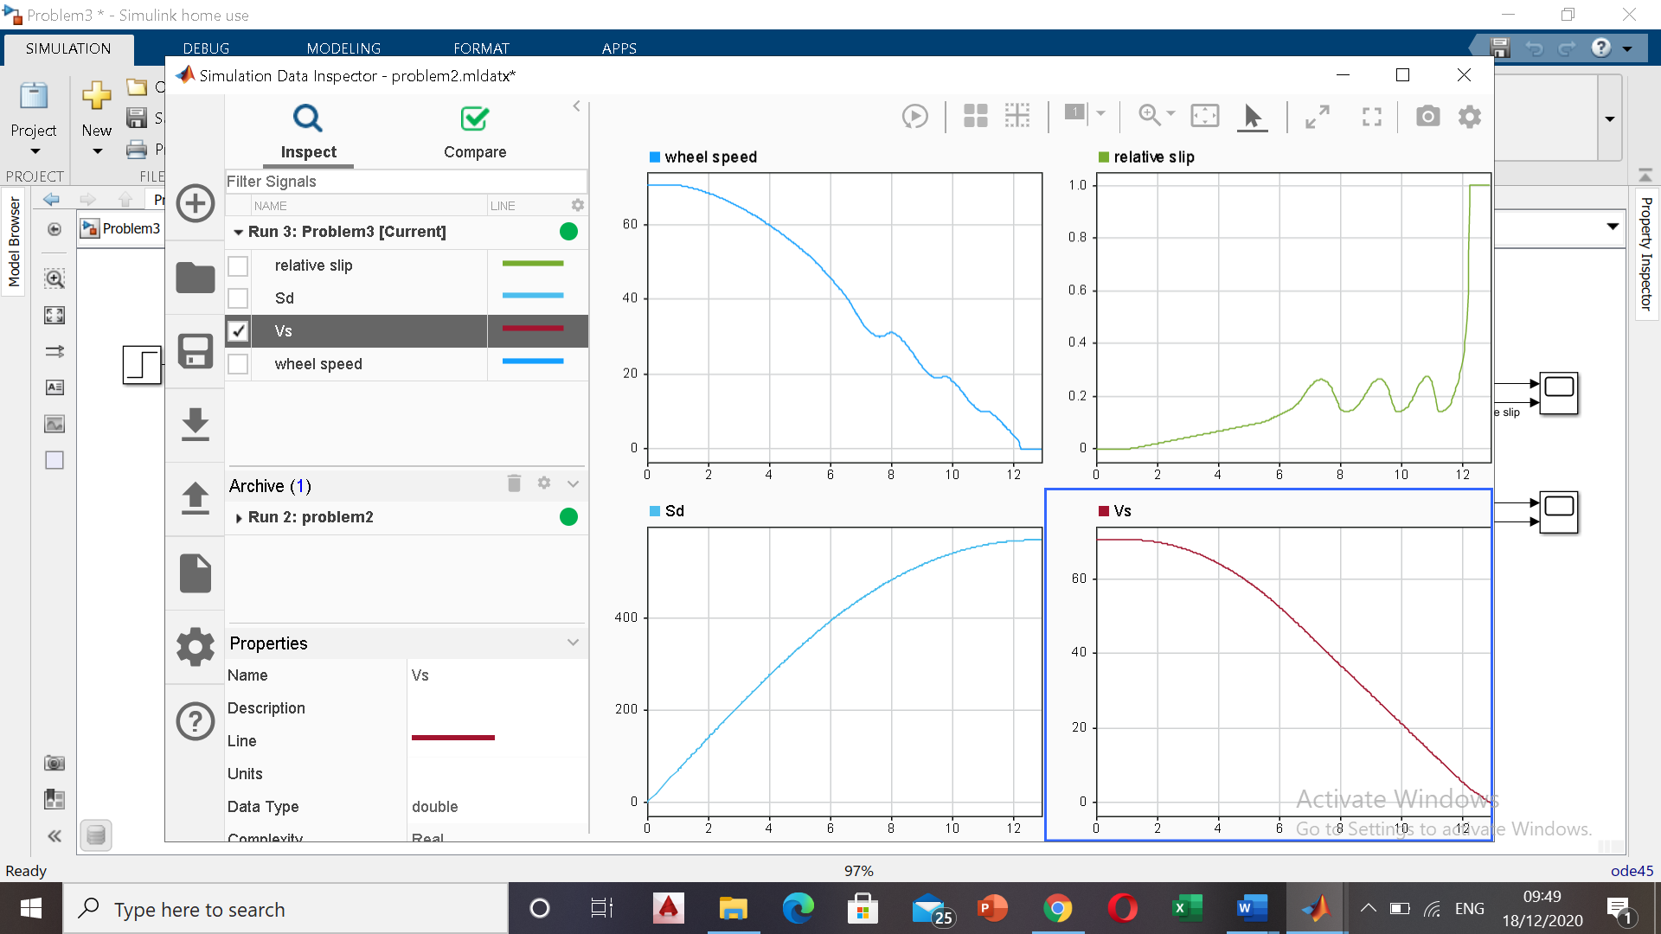

9.Callbacks

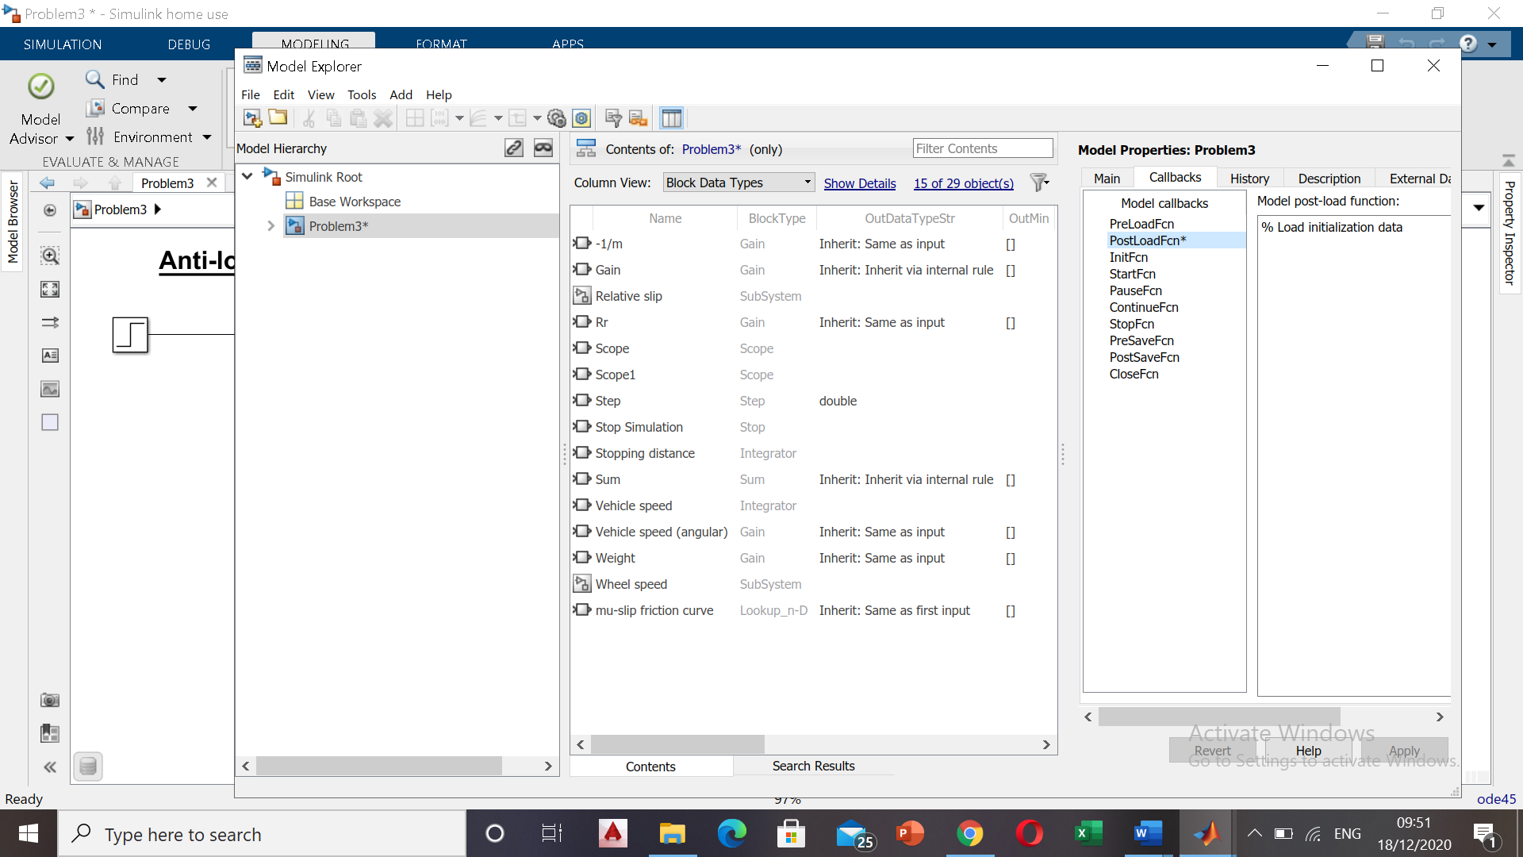

10. Signal building

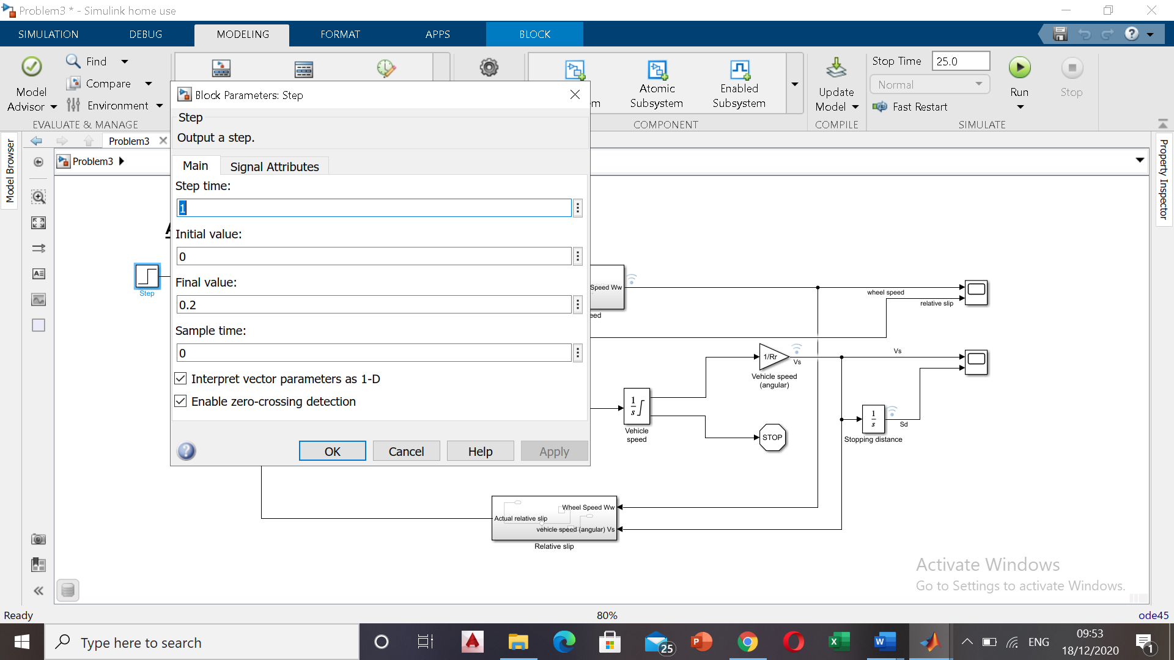

11.Look up table

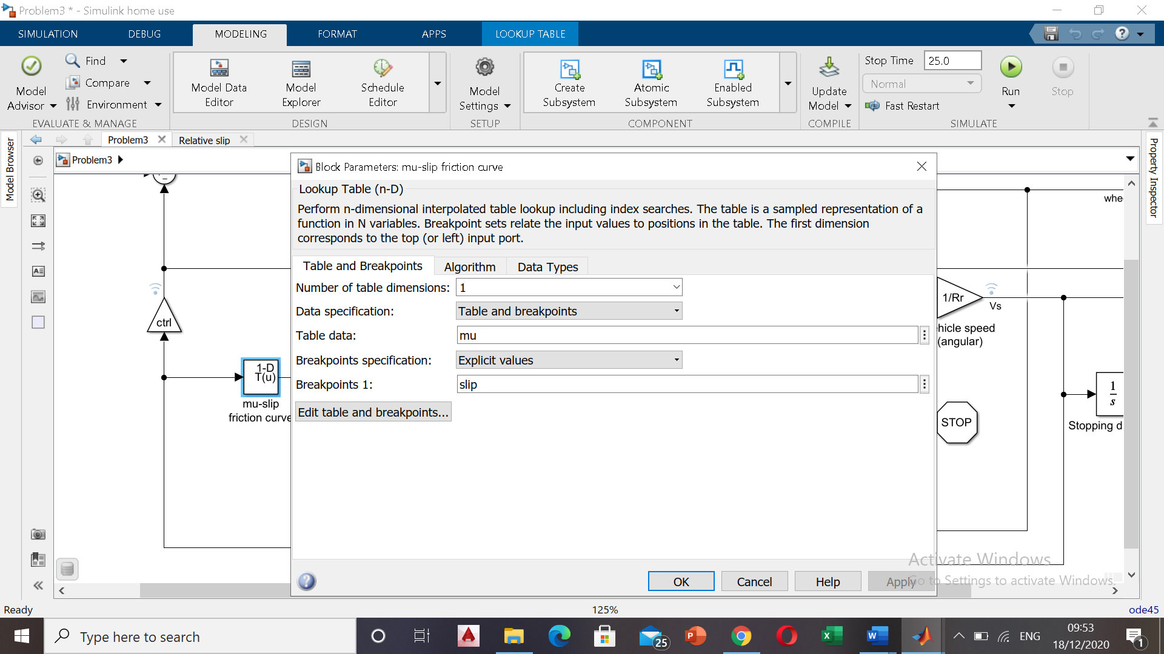

## 12.Result of Simulation

## 